



UW Events and RSOs

Jasmine Losovsky, Jocelyn Velasquez, Alon Levy, Vincent Tran, Brittney Oeur

INFO 200 Problem Statement | INFO 200 AB | Amy Oguejiofor

# 

# The Team

## Team Members

**Alon Levy:** I am a freshman in pre-sciences, attempting to major in Informatics. My skills are basic Java, robotics, and creativity. My responsibilities for the problem statement are writing the conclusion and summarizing my group’s research.

**Jasmine Losovsky:** I am a double degree student in both informatics and business administration. My skills include coding, effective communication, and creativity. My responsibilities for the problem statement are taking part in the research team, researching social media websites, and interviewing students about our topic.

**Jocelyn Velazquez:** I am currently a sophomore in HCDE looking to transfer into INFO. My skills primarily lie within UX/UI principles that focus on human-centered design. I have basic Java knowledge. My part of this team is on campus maps research– I will search for what information is already provided through maps and what can be improved upon.

**Brittney Oeur:** I am a senior majoring in Applied Computing and minoring in Informatics. My skills include having knowledge in C++ (such as algorithms and data structures) and graphic design. I will be focusing on the quality assurance for each group assignment—polishing up assignments, and ensuring that each task is being fulfilled and done correctly.

**Vincent Tran:** I am a second-year student with an intended major in Informatics. I have basic Java programming knowledge and am proficient in communicating ideas as well as questions to initiate discussion. I will be researching official UW websites and forums compiling its aspects toward our orientation of an effective problem statement.

## 

## Team Logistics & Policies

**Meetings:**

Our team will be meeting twice a week, every Tuesday (in class) and Wednesday (online). The designated meeting times are as follows:

1. Tuesdays: 4:30 pm - 5:20 pm (In lab)
2. Wednesdays: 4:00 pm - 5:00 pm (Discord Call)

We understand the importance of flexibility and are open to adjusting our meeting times if circumstances require it.

**Communications:**

We will communicate using Discord, utilizing its feature to message and call for our scheduled group meetings, in which we will discuss upcoming assignments. Our goal is to maintain clear, concise, and compassionate communication throughout our interactions. How we will execute that includes, posting a notification to the group an individual has completed their part of the group assignment and setting reminders as to what tasks need to be completed.

In the event of a disagreement or difference of opinion, we will speak to each other respectively and be active listeners. Striving to understand each other’s perspectives and working together to find resolutions that benefit the team.

Moreover, our designated turn-in person will play a crucial role in our assignment submissions. They will be responsible for notifying the group on the day of the deadline confirming when the assignment will be turned in and when it has been submitted. This practice will help keep the team informed and ensure a smooth workflow.

**File Storage:**

We will use a shared Google Drive to store our files for easy access and collaboration.

**Assignment Planning and Retrospective:**

Our group workflow will include a combination of in-person and online meetings. For every Tuesday, we will meet for labs to work and discuss the group assignment, and then on Wednesday, we will meet on Discord and continue to work on the assigned group assignment.

Once responsibilities are allocated, we will work on our own part individually, and ensure to finish the assignment at least a day before it is due. On the day of the deadline, one member will be responsible for submitting the assignment.

As a group, we will strive to establish a rotating system where one member will be the designated turn-person for the week, and then this role will be shifted to another team member in the subsequent week. This approach will help distribute the workload and promote fairness within the group.

# Problem Statement

## Introduction

Our team’s primary focus is to address a challenge within the University of Washington (UW) student community. The problem we will be investigating and addressing is the inadequate and disorganized information regarding the scheduling and locations of various events taking place on the UW campus. This includes club meetings, career fair events, and any other university-related gatherings.

We must address this problem because the current state of event information is convoluted and difficult to navigate. The confusion that this causes may lead to frustration and discouragement among students who wish to participate in these events.

Solving this problem would help UW students positively because they would be less confused and foster greater enthusiasm for event participation. This in turn can help enhance their UW experience. Attending these events can help students make friends, but also provides an opportunity to acquire new knowledge of something they may be interested in. This positive impact on students' social connections and educational experiences underscores the importance of addressing the issue.

## Research

**UW Official & RSO Directory Website:**

A simple search of “UW clubs” will display multiple websites all relating to student activities at the University of Washington. Some direct the user to the official UW website which gives general information on different group activities. Others send users to RSO (Registered Student Organizations) directories. Two websites stand out, the HUB (Husky Union Building) and the HuskyLink websites. The first focuses on how to create and find RSO’s and links to the directory. The second is the actual RSO Directory. The method of finding RSO’s can be confusing to some students.

**Handshake:**

This website is for job opportunities but is also a destination for career fairs throughout the UW campuses. However, the process to find such information requires signing in using UW credentials, and inputting career preferences, and basic information. This process can reduce the efficiency and speed of finding event information.

**Reddit Forum:**

A forum posted six years ago highlighted a concept that should be implemented today. The RSO Directory of the past was a newly improved version and had students commenting on its features. One student exclaimed that this is a necessity. Another student listed several concerns that have now been resolved. Once logged in, you have the ability to create a list of the organizations you are involved in. Regardless of the improvements, the website lacks the information for meetings and events from organizations. Many organizations do not post any public meeting events in the directory.

Figure 1 (Reddit Post):

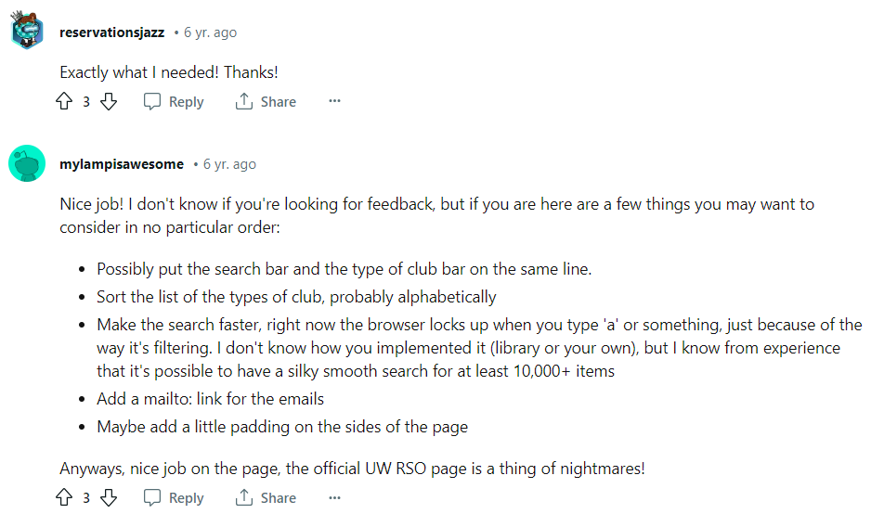

**Campus Maps:**

UW has a main map referred to as the Campus Map, it gives general directions of buildings but lacks the use of specific findings despite having a keyword search (*UW Campus Map*). At best, it allows you to click on buildings that lead to separate links. UW’s Sustainability map exists at a different link, it features a legend but the legend is currently not updated and contains no information. You have the option to select different map points at a time in order to prevent a cluttered map full of different symbols when selected they show which places include sustainable features such as bike repairs and LEED buildings. Clicking on a map point shows you a small description of each building’s sustainability. These features can be implemented into a campus RSO map for narrowing down to an area of focus. However, we noticed that the sustainability map does not have a hover feature that could greatly improve the time spent on the map to quickly find which club is being held there.

Differing from the general Campus map, the sustainability map is all in grayscale with the buildings being a darker shade so that the selected, colored map points stand out. If our map is in color like that of the campus one, the accessibility of color-blind people will have to be accounted for.

**Instagram:**

After deep diving into Instagram, a popular social media platform that both the UW students and the school itself use, to find more information about how people are hearing about the different events happening at UW. After doing my research, a couple of things have been concluded:

* Each major from UW posts their own events and career fairs in relation to their major/school on their own private Instagram pages. Some examples are: “asuwae” for arts and entertainment of UW “uwfosterschool” for the Foster School Of Business events “uwischool” for iSchool events and more.
* There is a page called “uofwa”, where they also post events that are happening on campus and outside of campus for UW students. However, there are no specific events and career fairs posted for different majors. Rather, it's a page that announces the general events that are happening for students. On the page, there are also posts of other information and announcements for UW.
* Each specific club/organization on campus has its own club page for specific events that happen in their clubs. Some examples are “huskyhillel”, a Jewish campus organization of UW Seattle “uwwinfo”, a diversity organization dedicated to empowering women in tech “hikingclubuw” for the hiking club on UW Seattle campus, and more.

After looking into all these Instagram pages, it is visible that there isn't one place that includes all events possible. Students have to follow on Instagram many different pages to get informed about different event meetings.

**People getting impacted in the problem space:**

After talking to multiple students on campus, I have written down each student’s opinion about the problem. Here is what some of them said:

* Gali, an HCDE student, takes an interest in both her major, psychology, and different clubs like the reading club and the “WiSE” club, a club for women in science and engineering. She said she often misses different events because she does not use social media as much and quite often misses many different events of her interest.
* Gracie, an Arts student who graduated the class of 2023, takes different interests in things on campus other than her major. She enjoys sports and likes to attend the games. Gracie also enjoys different foods and likes to attend different events for “foodies” like herself. She said she has a hard time following each sports team on Instagram and doesn’t even know who to follow for events that include food on campus. “It's quite overwhelming”, she says.
* Vincent, a computer science student at UW Bothell, takes an interest in tech and robotics. He likes to attend both UW Bothell and UW Seattle events but says it's hard to keep up with both campuses.

After talking to them, here are some points that can be written down:

* Some students want to attend events on both campuses
* Some students take an interest in multiple majors and clubs
* Some students like to attend more fun events like food and sports
* Some students don’t use social media to look into events

## We want to create a webpage that includes all events, organization meetings, club meetings, and career fairs, all on one page. A map or a page that lets you filter what you would like specifically to attend (career fairs, fun clubs, events of a specific major, sports games, fun events, etc.) so that students have everything in one place and don't have to look over multiple social media pages or multiple different websites to find what they want. The students want one webpage that has all the events possible.

## 

## Conclusion

In conclusion, my group recognizes the need for a more efficient and user-friendly solution to the problem of disorganized event information at UW. Through research, we found that there is a very limited amount of resources available for students to find events. Our target group, the students of UW, are constantly faced with the challenges of finding events and fairs. The current state of event information is scattered across various sources such as official websites, social media, and maps. Students are navigating through multiple platforms, missing events due to limited social media surrounding the event, and following an overwhelming amount of pages.

Our research has shown that UW students are diverse in interests, majors, preferences, and location. This diversity must be considered in designing a solution. Additionally, we are focusing on incorporating accessibility features such as for students with color blindness. Also, not every student uses social media heavily enough to keep track of event updates. This emphasizes the need for a platform that caters to a broader audience.

Next, we will continue exploring the aspects that should be included in our website. More specifically, we will start working on aspects of the UI and UX. More research will also be done to understand what the students of UW would want from such a platform.

## References

* *UW Campus Map*. Campus Maps. (n.d.). <https://www.washington.edu/maps/#>
* *Sustainability Map*. UW Sustainability. (n.d.). <https://sustainability.uw.edu/maps/>
* <https://www.washington.edu/studentlife/groups-activities/>
* <https://hub.washington.edu/get-involved/sao/rso-directory/>
* <https://huskylink.washington.edu/>
* <https://joinhandshake.com/>
* <https://www.reddit.com/r/udub/comments/791e5s/unofficial_improved_uw_rso_directory/?onetap_auto=true>

## Appendix

**Brainstorm Ideas:**

* Google Maps, Waze → lags and delays for route, doesn’t load in real time occasionally
* UW maps → missing designated areas (bathrooms, smoke areas, vending machines)
  + Possibly show event time and location (such as club meetings, career fair event, and more)
  + Maybe include the closest parking locations (include price?)
  + Find club times separated by major/ focus area

**Team Members:** Jasmine Losovsky, Jocelyn Velasquez, Alon Leavy, Vincent Tran, Brittney Oeur